Abstract— Logistics for cleaning the cities must be addressed form 2 perspectives: first one is related to human awareness to emphasize the importance and responsibility of citizens in recycling and reusing to avoid waste generation. the other one is operation to do an efficient waste management; not only because of the esthetical welfare since no litter will be spread on the streets, but to reduce public health problems as epidemics or plagues spreads, there is a logistics challenge behind it, that growths proportionally to the city size.
Data analysis of success story related to systematic garbage collection and waste disposal.
Data Science Project Term Proposal
(July 2018)
Roa G Andres., Montañez G Miguel, Students of MSc Computer Science, National University Bogotá, Colombia

Index Terms— path optimization, dynamical route calculation, data analysis, data simulation, mathematical model, GIS, environmental modelling, waste management.

Objectives

Performing some studies and analytics over a dataset that was found in kaggle repository, there will be establish a method for new data generation; these data must be coherent and consistent to the real wold data (therefore statistical factors of the analysed data are to be consider while generating new datasets). We expect to use generated data as a simulation of garbage production in the District on Engativa in Bogota, Colombia. Then this data will be used to feed an algorithm, which computed along other information such a population, density and trucks availability, help us to predict how the bins, where the solid waste is store, will behave.

Generated data and predictions are intended to design a second algorithm which allows to dynamically generate garbage collection routes, as a result we expect to deliver substantial resources saving, in terms of trucks usage, driver and crew work-hours that addresses to keep the city clean reducing the costs.

To achieve this general goal, we proposed to develop following specifics:

- Making a deep analysis over the dataset, to understand and define data behaviour according to its variations, dispersal, mean, medium and another statistical metrics.

- Planning a mathematical model to generate new data; for instances Routes, distances and volume of picked waste, those must be consistent with the relevant facts that where found during the data analysis.
- Create an algorithm implementing the mathematical model to generate new data applied at District of Engativa, these data include: container locations, hours, fill-levels, and last collection date. Then an application must upload this data into a Cloud data base, to have it available and accessible from a web application to be used in later phases of the research.
As optional objective depending on time and resources availability (time and Staff) we propose 4

- A visual representation, of generated data using a map of the district area, where it is possible to visualize containers locations and its full filament level: framed in a colour standard, this information can be used to create a heat map to cluster containers according to the necessity to collect them.
Following features and further activities are out of the scope of this project including graph generation within the conformed container clusters, those graph must be expressed in terms of nodes (streets intersections) edges (the streets them self) directions (traffic way or direction) and weights (as the sum of volume reported by the sensors on the containers allocated in one street). On this graphs an optimal suggested route is generate, as valuable information to assign trucks for the collection depending on his transportation capacity.

Term Definitions

Geographic information system (GIS): is a system that uses special encoding that makes easier dealing with spatial information as locations, distances, surfaces and routes, it uses a special coordinate notation and a set of function for performing spatial operation, some of them have feature to visualize data generally on maps. Based on (Clarke, 1986)

Municipal Solid Waste (MSW): this consist of everyday items discarded by public, it is related to municipality because, this is the institution responsible for managing (collection, transportation, segregation, reuse & disposal) these kind of material.

Internet of Things (IoT): it is a paradigm with a simple principal that things can do better if they share information, therefore the common devices are being equipped with sensors, which are continuously retrieving and exchanging data across the network to make human-machine or machine-machine interactions more practical and useful for the society.

Ultrasonic Measurement: ultrasonic waves are the ones whose frequency is around 20 kilohertz, which is not understandable to human ears, these waves are used with several purposes such as radar scanning for finding objects. A simple use is to determine the distance of object based in a basic calculation S_{peed} = D_{istance}/T_{ime} consisting in the time the waves took for return to the forecasting point after collision with and object, it is knows that ultrasonic speed propagation in the air at 20 Celsius degrees is 344 (m/s).

Radio Frequency Identification (RFID): is a technology to automatically identify and track tags attached to objects, the tags contains electronic stored information these element may operate at long distances without the constraint of direct line of visibility.

Wireless Sensor Network (WSN): refers to a spatially dispersed and dedicated sensors; for monitoring and recording physical conditions of the environment and organizing the collected data to a central location. Textually taken from (Dargie & Poellabauer, 2010).

Software Defined Networking (SDN): are a set of techniques to design and create networks where the control is detached from hardware and gives the control to and appliance named as controller. Further reading in (Fergougui, El, Alaoui, Benzekki, & Elalaoui, 2017)

Literature Review

The importance of Municipal Solid Waste (MSW) is exposed by (Louati, Son, & Chabchoub, 2018) they propose a heuristic-based Smart routing algorithm for MSW collection, in order to minimize the environmental effects given the waste production scenario. The algorithm was coded in python scripts in ArcGIS, relevant facts such as operational time of vehicles, routes and total travel distance were considered. This algorithm was validated in a real case study in Sfax city, Tunisia. A novel optimization model given the algorithm was delivered and the results were compared against de old scenario data, using a multi-criteria decision methods namely PROMETHEE in terms of environment and economic criteria.

A similar mathematical model was tested by (Tirkolaee, Mahdavi, & Mehdi Seyyed Esfahani, 2018) to solve the garbage collection problem. They took multiple trips, drives and crew times as variables to build a function, whose objective was to minimize the total traversed distances and cost of transportation vehicles usage, to fit the problem they improved a hybrid simulated annealing algorithm, that show to be acceptable compared with the current solution method.

A different scenario was studied by (Nowakowski, 2017) here the importance of collecting electronic waste for recycling purposes is highlighted. They assume that main fact in collection process are storage and transportation; so they designed a Integer linear programming problem to maximize the amount of waste transported within the containers for the recycling routes, as a result they got a framework for packing and collecting electronic waste that was implemented by several collection companies across Poland.

A group of Peruvian researchers concerned about waste management optimization use an approach combining operational research techniques and life cycle assessment; to establish strategic collection points for general and recyclable waste, they propose a “effective-collection route system” for compactor trucks, the output shows the number of containers as well as the places were those must be located, an heuristic solution based on the Vehicle Routing Problem was implemented and tested in the district of comas in Lima, Peru. (Gilardino, Rojas, Mattos, Larrea-Gallegos, & Vázquez-Rowe, 2017) then a sensitivity analysis was performed varying three parameters, computing the results they found out that 50% of the current amount of trucks were enough to satisfy collection in the district.

A closer to data study was carried out in Bumehen a province of Teheran, Iran. The data used encompasses the average weights, time taken for collection and transportation of MSW align to GIS software, all these data was collected and later used to generate map of classes, route waste type, generation of waste per capita, after that along with other information such as: density, population, waste generation rate, existing routes and trucks capacity, it was possible to come up with a better transport station locations and appropriate routes were for trucks were designed. After that a qualitative analysis of dry waste exposed that plastics, cardboard and paper that have a 8,6% , 8.6% and 8,3% respectively of the total amount of the city waste, this let propose a strategy to collect this material for recycling (Dehghani, Biati, Mirzaeian, & Heidarinejad, 2018).

(de Morais, Ramos, & Barbosa-Póvoa, 2019) introduce the concept of dynamic waste collection as dynamic routes which exploit the real-time information of garbage-bins fill-level, in section 4 they made the comparison between static and dynamic Inventory Routing Problem that with a medium term
approach it was possible to visit the bins that were more fulled reducing the number of times a bins must be visited and visiting a higher number of bins than could be visited using the static strategy.

Based on the same concept of dynamic waste collection a dynamic operation leveraged in IoT strategy, was formulated by (Fadda, Gobbato, Perboli, Rosano, & Tadei, 2018) and was applied in Torino, Italy as case study. They were able to plan the weekly waste collection activities without imposing a fixed periodic routes, instead of that they calculate the routes dynamically according to the city necessities, they manage to implement the solution increasing the overall operation efficiency and significantly saving cost.
A different problem concerning data absence was exposed, here the authors states that Geolocated specific domain data-set are difficult to find for several reasons, including privacy politics or economics markets. Foursquare and Facebook are performing real time analytics base on the data their users provide them via their Geo-located applications.

Social network generate large amounts of data such as Spatial-textual data in the case of tweeter or plain Spatial data as GPS traces, given this lack of information (Doudali, Dimitra, Konstantinou, Ioannis, Koziris & Nectarios, 2018) have presented Spaten which they define as an Open-Source configurable Spatio-Temporal and textual dataset generator. It uses Google Maps API, to extract GPS traces and combine them with real POIs from comments and feed for TripAdvisor users, then they load the generated data in a Big-Data noSQL system, aiming to enable data scientists to use this data in further analysis.

Case Study

We take as reference model the one described by (Fadda et al., 2018) which is related to waste collection operation on urban areas and how to apply IoT strategies to make the process more efficient. The solution was adopted by “Cidiu Servizi S.p.A” an Italian company that provides waste management services in 2018, to serve some municipalities in outside boundaries of Torino, Italy. Additional information of the project deployment can be found at (https://onde.city/progetto/)

In the reading they propose a solution under the optimization of the Networking data during waste generation phase in the garbage management life cycle, there they propose innovation in three ways:

- Amplifying the flexibility by considering all types of waste and removing the constraint of emptying each dumpster at a fixed weekly-frequency, instead of this the use and IoT approach combining a historical data source of vehicle routes, weights and a sensor network, the retrieved data is given to a mathematical heuristic algorithm; that provide collection solutions, those solutions are complemented with social campaign for make aware citizens of the importance of eliminating contamination trough reducing waste generation, where more waste is being produced.

- The adoption of a methodology to deploy the solution using GUEST OR methodology, which is a business oriented but supports complex multiple-actors systems such as the presented in the waste-collection scenario.
- A knowledge base containing the system needs and the stakeholder’s desires was created under the outputs of the methodology. These allows to define clear requirements and to provide the stakeholders with a decision-making tool to address to solution convergence.
The computational test where performed to assess the model and validate if significant improvements were made on the whole process.

Dataset Description.

We found a dataset with information of waste unload location, the collection route number, waste type and load weight between 2004 and 2016 in the city of Austin- Texas, USA, the dataset composes of 564403 records. These date was publish for public use and it is available in (https://www.kaggle.com/jboysen/austin-waste#austin_waste_and_diversion.csv)

When it was created under 4 motivations according owner declarations:

- How much trash is Austin generating?
- Which are the trashiest routes? Who recycles the best?
- Any seasonal changes?
- Try to predict trash route usage from historical trash data

Dataset Collection.

The data has being collected for the collection operators in association with the city hall of Austin Texas. This data compiles information related to waste, diversion, routes and schedules of garbage collection between June 2004 & December 2017 it is publish for public use in https://www.kaggle.com/jboysen/austin-waste#austin_waste_and_diversion.csv and this is related to some geographical data of the routes that is available in following link: https://data.world/cityofaustin/azhh-4hg8
It is composed of 2 files: the first one is 8 columns, 184 records in the tables below we show a brief description of the data and its structure:

Route Data Set
Name | type | size | description | Example
LANDFILL | Characters  categorical | 30 | the name of the landfill it has the same value for all the records | TDS
the_geom | Location  continuous | 10000 | This are geographical shapes (Multipolygons) that describe the planes route that trucks must go through | MULTIPOLYGON (((-97.70618263474258 30.367416007124167, -97.70723083139684 30.36791375533362, …)))
GARB_RT | Characters  continuous | 10 | An alpha-numerical code to distinguish identify each route | PH10,PT20,PF33,PAF72
GARB_DAY | Characters  categorical | 10 | A day of the week in which the route was typically settled | Monday, Tuesday, Wednesday, Thursday, Friday
GARB_SUP | Characters  categorical | 10 | Last name of the supervisor assigned to watch over | Carnline, Klair, Joyner, Clark, Williams, Gilbert, Castillo
SUPER_NUM | Number  categorical | 3 | a numeric code to identify supervisor | 596, 400, 800, 697, 500
OP_TYPE | Characters  categorical | 4 | the collection strategy | Auto , Semi
RT_OLD | Characters  continuous | 10 | old id code for the route | PAM84, PAH75, PH23, PAM64, PM23
Table 1: Dataset Route File data Description.

The second file is 8 columns, 564403 records

Garbage Historical Loads
Name | type | size | description | Example
dropoff_site | Characters | 30 | Name of the disposal place or Landfill | HORNSBY BEND, WINNEBAGO, COMMERCIAL METALS, MRF, WILCAB, STEINER LANDFILL
load_id | Numeric | 6 | an id code to track the load and the content of it | 104025, 101276, 101235, 101234, 101261
load_time | Date | ## | date when the truck was unloaded, Format (D/M/Y) | 20/11/2013 1:29:00 p. m, 04/10/2004 2:17:00 p. m., 10/05/2012 12:00:00 p. m.
load_type | Characters | 30 | the kind of waste that was collected in that route | RECYCLING - SINGLE STREAM, SWEEPING, BRUSH, GARBAGE COLLECTIONS, BULK, YARD TRIMMING
load_weight | Numeric | 6 | the quantity volume of collection in the route (litters) | 23480, 7640, 22000, 13320, 21300
report_date | Date | ## | date when the information was reported, Format (D/M/Y) | 20/11/2013  06/11/2013  21/11/2013  27/01/2009
route_number | Characters | 10 | An alpha-numerical code to distinguish identify each route | PAT08, PAT07, RWBU14, RWBU13, DT2
route_type | Characters | 30 | the kind of waste that was collected in that route | STREET CLEANING-DOWNTOWN, NHOUSE - RECYCLING, BULK, STREET CLEANING-RESIDENTIAL, SWEEPER DUMPSITES, BRUSH, KAB, HAULING

Table 2: Dataset Garbage Historical Loads File data Description.

Dataset Organization.
The data is structured as a relational model, it is made of 2 tables: routes, loads diversion, there is a single relation between them this is to say that one route may have several records of loads, no database implementation is required since data is arranged in 2 separated coma (CSV) which is an allowed format in python which is the tool that we are going to use to perform the analysis.

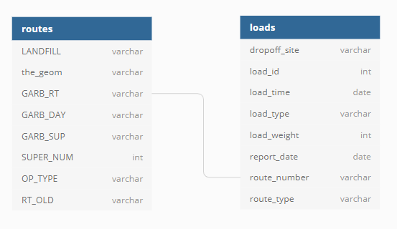

Figure 1: dataset structure

Data Cleansing.

Distance: as the geographical point were relevant information for the model but the pair of coordinates was not pretty useful, we decided to transform those point into distances using the Harvesine formula to calculate the distance over a sphere surface. The sum of all the distances between the points that shape each route was the distance of the whole route, we expect this helps us to understand and provide some further insights, we use kilometres as distance unit.

Variable Reduction: we consider that some information such as supervisor, supervisor code was not really important for what we expected to see, therefore we dispense with those columns, another couple of

variables did not have a significant difference between the (load_type, route_type) so we decide to remove route_type that was quite specific and we kept the other one to work with it, besides after calculating route distances we delete the_geom column as we won’t use it in afterwards analysis.

Data Frame Merge: next step was to put the records of the two tables together so we join the tables using the common column (GARB_RT and route_number) there was a slight reduction on the number of records because there were some load that did not have integrity with the routes defined therefore that ones were eliminated.

Variable Casting: as we want to compute some mathematical operations over columns for getting statistical measures such as the mean, standard deviation, min and max values we convert load_weight and route_distance into numeric values.

Nan Value Filling: there were some nan values particularly on load_weight and route_distance columns we group them by route, then we calculate the average weight and average distance of those groups and we use this value to fill the nan values, with the average value of the group that that record belonged.

Values Normalization: we wanted numeric values to be very close in order to compare them the easiest possible, thus we normalize variables using a divide transformation to calculate a value near to the other variable quantity range.

Exploratory data Analysis.

Before starting any statistical analysis we want to establish what routes were showing an optimal performance, in other words which routes are capable of picking larger amounts of waste while travelling less distances, since we want the other routes to have a similar behaviour. So the most important variables to be consider are (Weight Loads & Route Distances) using this as starting point we extract general centric and deviation measures, the results are show below.

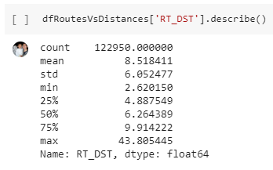

Figure 2: Route Distances Statistical masurements.

According to this information, we can observe that if the mean is around 8,5 Km length a route with 43,8 Km is probably an outlier as a consequence we want to remove all routes whose length it greater than 35 km. another surprising factor is the standard deviation which is very close to the mean this insight lead us to think that distances are not Gaussian Distributed.

Load Weight

Instead of calculating the general load weight statistic measurement, we want to group them by routes in such a way that we can see the general information for each route. This may lead us to better insight maybe the geographic location or collection day have an influence on waste volume produced, we found out following facts.

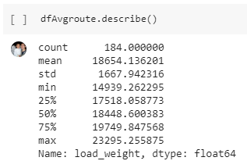
Figure 3: Load_weigth Statistical masurements.

If the mean is about 18654 litters and the minimum is around 14936 there is a difference of 3715 litters between them, because of that we expected the same distance in the opposite direction this it to say that we expected a maximum value of 22369, but it is actually 23295 litters so we see that loads are closer to the 25% quartile.

In order to confirm this hypothesis we will draw a frequency histogram so that we can look deeper into data.

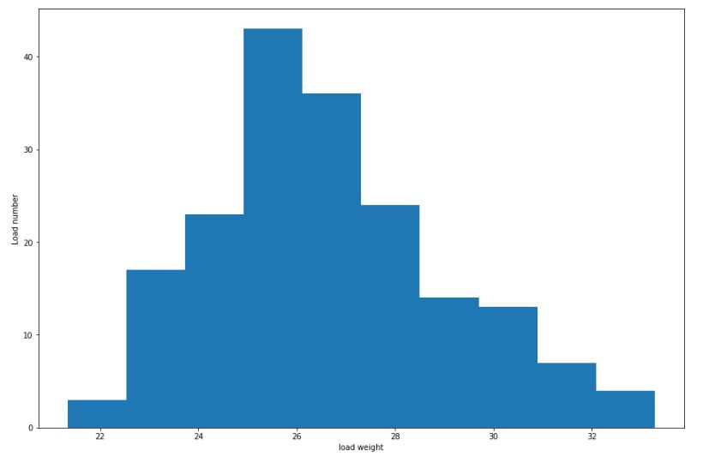
Figure 4: Histogram of general loads Frequencies

In fact the histogram shows the load data is concentrated near to the 25% quartile so we can affirm that it is skewed to the right, another graphic such as a boxplot may help us visualizing the difference with the mean and its quartiles.

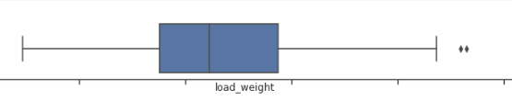

Figure 5: General loads Plotbox

In next graph we want to show the frequency distribution of load grouped by routes this will probably show some patterns of waste generation and may help us understand the how if there is any relation among routes or give us a clue about the high deviation we get in the very first data description.

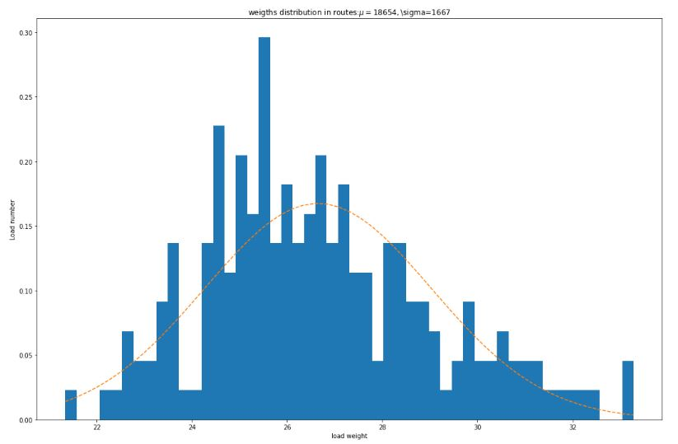
Figure 6: Histogram of loads grouped by route.

Here we use a line close to a Gaussian distribution this help us to confirm that this data does not fit this pattern. And it is also very explicit that values below 22000 litters and 35000 are outliers.

For the categorical information we use an aggregation approach; this let us see if there are any hidden patterns that affect garbage generation. Among relevant categorical variables of this data set we find collection day and type of load, then we group them as show below.

We will start by classifying the days of the week it is possible that some day’s garbage is generated faster than others.

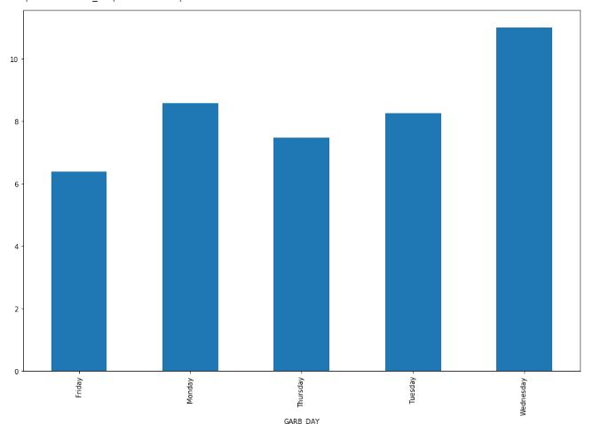

Figure 7: Travelled Distance by day of the Week.

As the garbage is collected Monday to Friday not on weekend, we thought there was a high probability that garbage was accumulated during the weekend, therefore Monday would be the day when more garbage was collected, but it is indeed the second day and the most critical one is Wednesday what is an unexpected result.

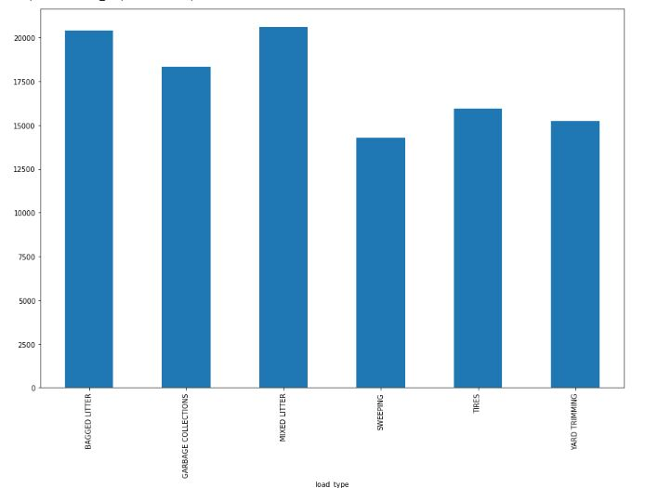
Figure 8: Travelled Distance by day of the Week.

The second categorical aggrupation we made was load type, this shows a good planning of collection scheme, because whenever non common types such as tyres and yard trimmings are picked no resources are being misused, it is reflected in the load volume that are pretty similar to the volume of the common ones. No significance difference is showed.

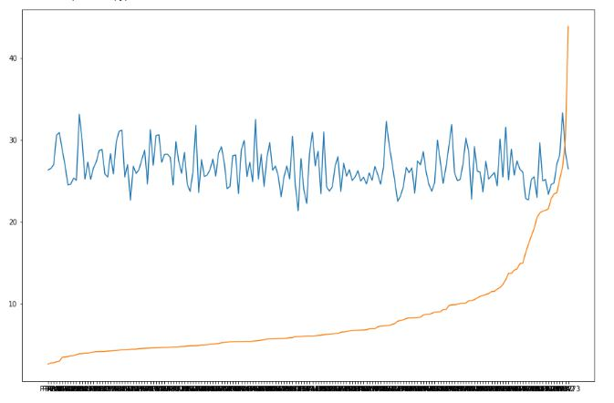
Figure 9: Relation between Route distance (Km) and amount of waste collected in (Lts).

One of the prior forecast we did, was about the relation between loads and distances, we thought the longer the travel distance the larger the volume collected. So we organized routes based on its distances ascending (the red line) and we lay them out next to the z-score of loads (in blue) with the assumption there was a kind of correlation, however it surprises us to see that there was not, the distances kept growing while the loads remained bouncing in the same scope.

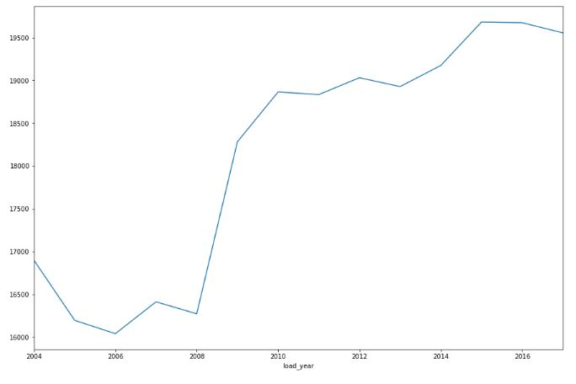
Figure 10: Waste production evolution between 2004 and 2017.

An interesting pattern we discover after grouping information by years and the average of garbage production, is that in recent years the amount of garbage has being continuously, increasing a dramatic augmentation took place in 2008 and from that moment on it has being growing. Which is worrying taking into account the natural effects that are affecting our planet such as the big amount of contamination and the climate change.

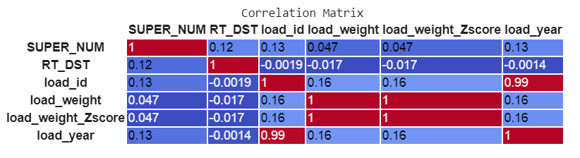
Figure 11: Continuous Variables correlation.

The software we used include all columns were data has numerical types for delivering the matrix, nonetheless in the case of super_num and load_id those were used as identification codes only, and load_weight_Zscore is a variable directly extracted from, thus we will work with RT_DST, load_weight, and load_year but when we measure the relation between them, we see that it is really low there not to say insignificant.

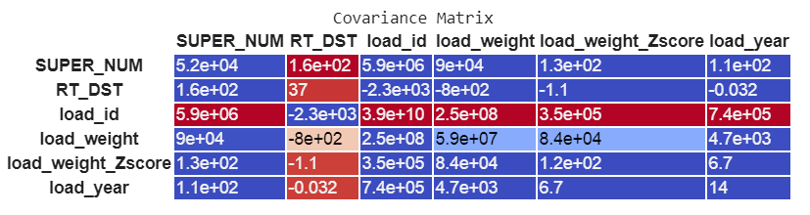
Figure 12: Continuous Variables Co-variation.

Here a covariance matrix was generated the data is hard to read into since there are a wide scope of numbers but according to the colour standard the red cells are close to 1 the blue ones are close to 0 and the other colours are in between.

Collection Routes Geographical representation.

The geographical information is useful to determine if there is any relation between the location and the waste production, maybe there should be a higher rate of it, in industrial or residential areas. To evaluate this we need to calculate a new variable that tell us how far a route is from some important points such as: the city centre or the geographical coordinates of enterprise clusters, or residential areas.

Before going that far in calculations we want to execute an heuristic analysis by drawing on a map some routes, that are showing good performance in green, the ones whit medium performance in yellow and that ones with low performance in red, an compare them to see if they have any kind of geographical distribution. We draw only 30 routes, ten of each to avoid crowding the map with info that is likely to be difficult to understand.

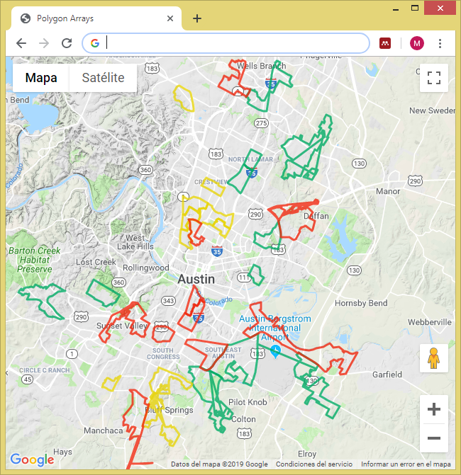
Figure 13: collection routes map by average load.

after this visualization we could see a set of routes near to the north centre that are having a similar behaviour of middle performance, but for the green and red one it quite difficult to determine a pattern this help us decide that spend time preparing data for geographical calculations that won’t lead us to major conclusion was not worthy.

Theoretical considerations

As for this exercise we want to work calculating routes in terms of distances, where graph models have proven to be functional we need to be aware of some definitions to be that have been studied in the graph theory for the next phases of this research.

Eulerian path: is a trail in a finite graph which visits every edge exactly once, it is different to the eulerian cycle because this last one need to start and finish in the same node that is not the case for this specific problem.

Directed graph: is a graph whose vertices are connected by edges that have a specific direction between them, so the way to go from one vertex to the other is in that direction for example: if a graph has a direction form the node A to B; A→B it is possible to go directly from A to B but it is not possible to go directly in the other way this is to say form B to A.

Strongly connected graph: a graph is said to be strongly connected if there is a path that connects every vertex, or if every vertex can be reached and there is a edge to reach another vertex.

Balanced graph: a graph is said to be balance if for every vertex in the graph the number of incoming edges (Vin) is equal to the number of outgoing edges (Vout): so Vin = Vout.
Euler have shown that there is possible to find an Eulerian path if the graph is both strongly connected and balanced.

Mathematical Model

This is the very first version of a mathematical model to search for a solution it need to be perfected.

Let a graph G be the alignment of the streets allocated in a geographical region where the streets are represented by Edges and the connections between them are represented by nodes. We may need to have into account edges directions that in the case of the traffic is the route way.

Specifically for the garbage collection problem we are interested in the streets which have a priority of 1 or 2.

Let G; the graph

Let i; each one of the street segments shaping the graph

Let n; the number of streets in the graph

Let mi; the number of container in i

Let Di ; the distance of each segment of street i which is limited by the intersection with other streets

Let Vi; the sum of the fulfilment percentages stored in the containers along the street i

Let Xi; the relation Vi/Di that will count as the weight of each edge in litters by meter

Let C; the load capacity on each garbage Truck.

Then the objective function become maximizing the collected volume & reducing total travelled distance

Objective: max and min

Other measurable indicators are:

Route Distance RD = ;
Route Volume RV= ;
Number of dumpster in the Route RM=

First restriction is going through all the edges in the graph considering the reduction of the total travel distance, this is achievable if we pass by each street only once what is known in graph theory as an Eulerian path.

Other important restriction are

Traffic Speed TS = km/h

Route Time RT = TS * RD * 60 and Delay Time DT = RM * [5,10] then
Total Time per Route = RT + DT

If a truck consumes in average a gallon of fuel each 20 Km then the Fuel Consumption.

FC = RD/20 km (in gallons) or RD/5,3 (in litters)

Simulation

After doing the basic dataset cleansing and determining the waste generation behaviour, the relations between factors and understanding the facts affecting the collection process with data of Austin Texas. We try to reproduce some similar information for a one District in Bogota.

For that purpose we download geographical data from Bogota, the data contains the ways and streets locations, as well as the polygons describing the shape of neighbourhoods in this city, this data is available in the website of Unidad Administrativa Especial de Catastro Distrital
(https://www.ideca.gov.co/datos-de-referencia)

First thing we step with these data was to check which ways belonged to each neighbourhood, then we check which neighbourhoods were inside each District in order to determine all the ways that belonged to a specific District, we choose Engativa as target for the research because it is the district where most garbage dumpster are allocated, so that we may have more detailed insights of data and use them to generalize other districts in the city.

We write a function to generate random points within following constraints: (1) the points must be located in streets labelled with primary or secondary tag only, (2) the space between 2 points must be at least 65 meter. That represents the location of dumpsters on the streets, we generate 2868 as a whole, which is the same amount of dumpster currently in Engativa District.

We also write a function to simulate fulfilment levels in these points, the levels were generated using the distribution of garbage production found in Austin, Texas dataset. We generate a number between 1 to 100 that represent the fulfilment percentage in each dumpster using the next Gaussian number generator of java and we skewed it by adding the mean and standard deviation values

Data Storage Scheme
On the top of geographical data from Bogota a relational and spatial data base model was created, we used Postgres and Postgis to store the generated information, After that we built a web service under simple HTTP protocol that provide access to these information that will be used later on as data provider for the analytical process.

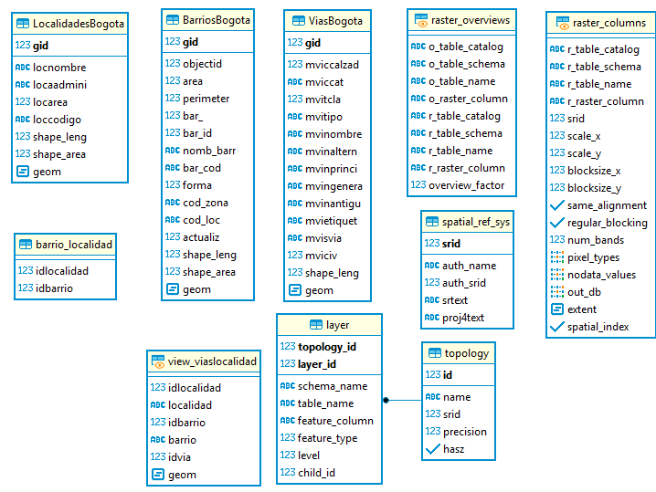
Figure 14: Catastro Bogota geographical dataset model.

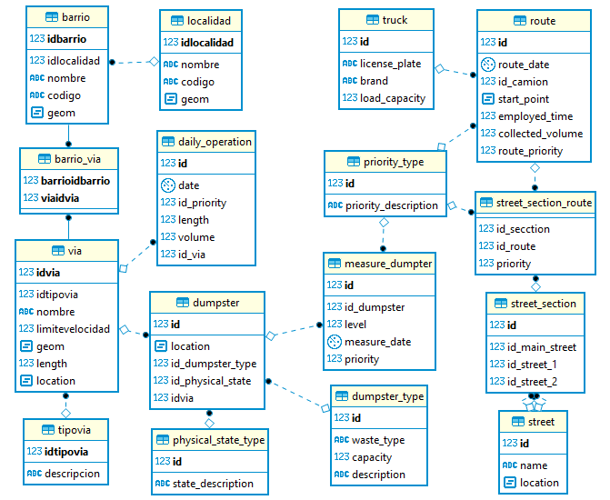

Figure 15: new Geographical model
generated for data simulation.

Prior Visualization

To build a graphical representation of simulated data, we use a Google maps service to show container distributions and its fulfilment level, a colour was assigned to containers encoding its fulfilment level as described in the following table.

Fillement Level Percentage | Description | Colour
X = 0 | Empty | Black
0 < X <30 | Low | Green
30 < X < 55 | Medium | Yellow
55 < X < 80 | High | Orange
80 < X | Full | Red
Table 3: fulfilment level colour-scheme

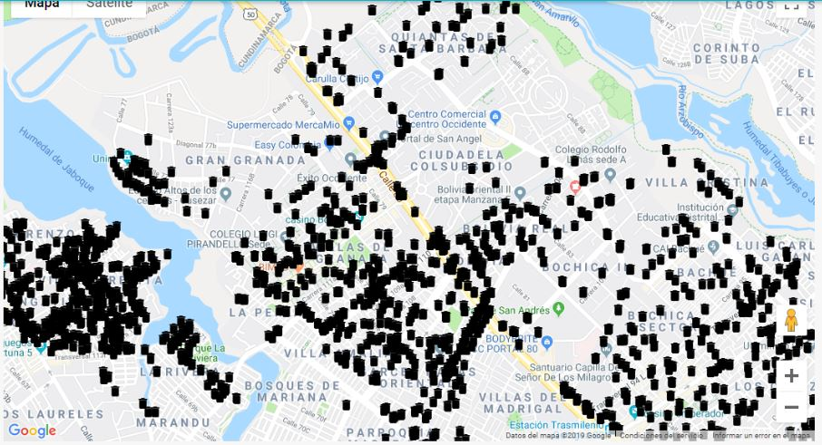
Figure 16: Random container location.

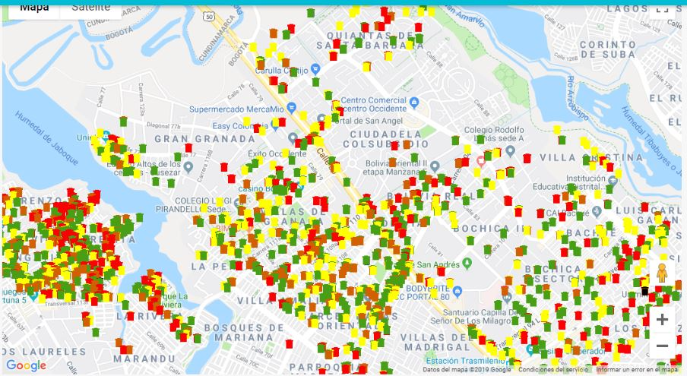
Figure 17: Simulated garbage generation in containers.

Analytics

Our mathematical model uses an optimization function that aims to maximize the collected volume by travelling the possible least distance, to achieve this it uses a graph were edges are the high priority streets, so we prioritized the streets we wanted to serve.

To do so we generate a vector for each street in the district. This vector describes the total volume of waste generated by street, its length, the Date and priority this last one is calculated based on and the number of container that are full, high, medium and low level according to rules stated in the table below, Only streets with priority 1 or 2 were included in the collection operation.

Street Priority | Container level | Description
1 | F>0 | there is at least one Container Full
2 | H>0 | there is at least one Container in high level
3 | M>0 | there are only Medium level containers along
4 | L>0 | there are only low containers along
Table 4: Street Priorities base on container levels

After determining the streets we wanted to server, we need to estimate the number of required trucks to perform the operation, a basic calculation was made using the total volume of waste along the streets vector array, then we split that value in the estimated volume capacity of a standard truck which is 37500 litters approximately 15 tons when compressed.

Next step was a clustering method A k means approach was used to group those streets using the Euclidean distance between the centre points of each street, the idea behind this approach is to find an equitative of element distribution in each group, with the restriction those must be near minimizing the distance of each element to the centre point of the group that is calculated as the mean of the criteria variable which in these case is location. For these reason we add one more function with a geographical point indicating the centroid of each street using these as a parameter for the clustering function.

As most of the previous simulation phases were done using java, we search for an open source project that implement the k-mean method with the same programing language, indeed we found source-code, however the source we found did not fit exactly our needs, therefore we should tailor to obtain better results.

Optimal number of clusters is mean to be close to the estimated number of trucks required, in such a way that each truck is assigned to a cluster, nonetheless it is very likely that for some clusters the total volume exceeds the truck capacity, then more than one truck would be required to server each cluster. To minimize this situation we used an elbow convergence strategy trying to limit the cluster size, grouping streets whose total volume did not exceed the truck capacity but in such a way that they can be considered to be spatially close.

At this point we face a challenge it was to determine a good number of clusters to avoiding over fitting the model, to resolve this we use the elbow convergence strategy, we used the efficient distance function calculated as the sum on the distances between the centroid of the cluster to each element in the clusters in all clusters.

We realized that the difference in the distance function improve substantially for the first clusters iterations, but as the number of clusters growth the change in the efficient distance function did not enhanced significantly, so the challenge was to find when to stop clustering iteration since no significant change was to be obtained. For that we use an analytical approach assessing the slope of distance function in 2 consecutive clusters we follow this criteria: first when there was a sudden change in 2 k distance function slope or when the slope was between 0.5 or -0.5. In following example that criteria is met between 9 and 10 clusters.

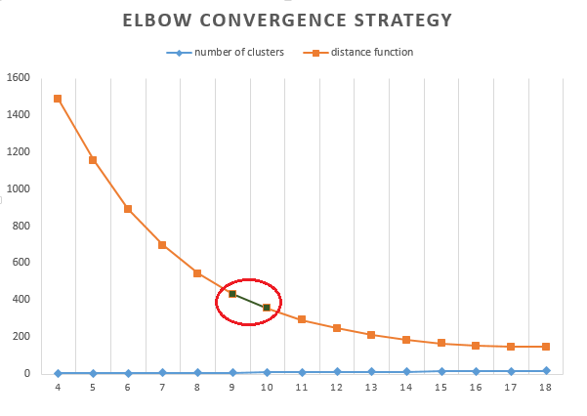
Figure 18: Elbow Strategy Slope Analysis.

Data Visualization

Once the number of cluster was found and a good clustering model was generated we built interactive user interface to draw the results, (the containers and the clustered streets) we wanted to show the raster map of Engativa, so we used Google Api as map provider the results can be observed in following images.

The application interface was built using this technology:
- back-end component: Java, Spring, JPA, JWT
- front.end component: Angular 8, prime NG, git, Google Map API
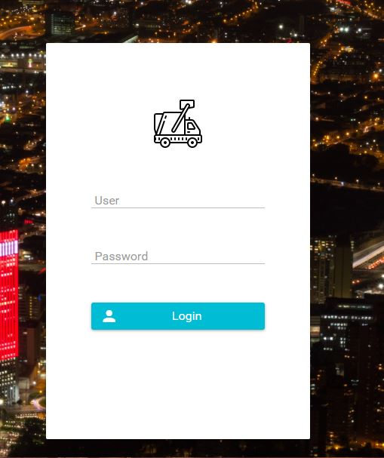
Figure 19: Web Application Landing Page.

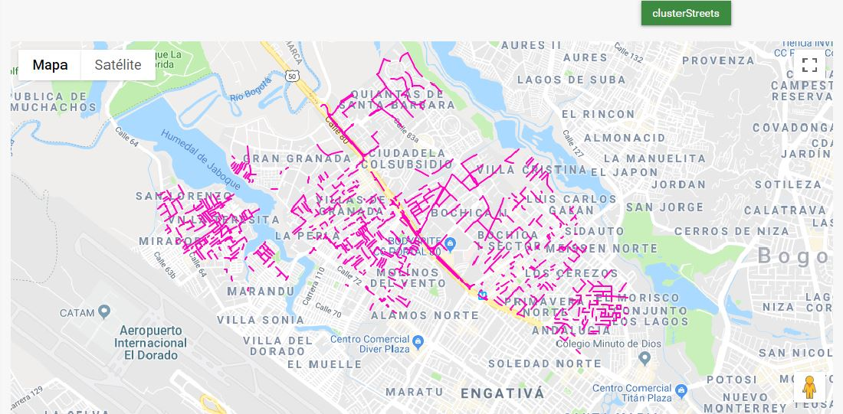
Figure 20: Prioritized streets clustered using K=1.

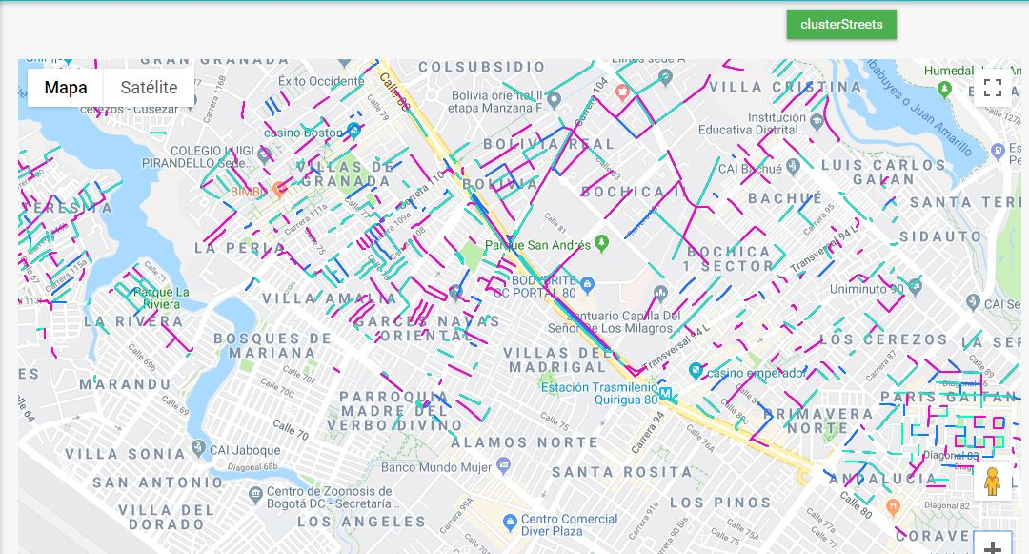
Figure 21: Prioritized streets clustered using K=3.

An interesting fact we came across is that prioritized streets are not fully connected, so under the collection approach we proposed, truck should travel across some streets were no collection is required just to arrive to the streets where high priority dumpsters are allocated, that is going to increase the travel distance thus the optimization function is going to be impacted reflecting this model may not have optimal performance.

Some technical issues are affecting the clustering visualization these need to be reviewed because the visual representation is not showing the real clustering of streets

Conclusions

It very probable that real garbage production in Bogota does not match the distribution of Austin, Texas. So although the path search algorithm is generic, it will need to be adjusted along with IoT network when the model is implemented in a real environment.

We require some operational data such as number of trucks used, total travel distance, operation time and waste load in order to compare the proposed model to determine if it delivers substantial improvement to the collection operation.

The generated data should be analysed as historical resource so further patterns and insights can be discovered and used build more accurate schemas to continue improving the operation, particularly to leverage the recycling process which is still insufficient when compared to recycling operations in Mexico or Sweden.

Future Works

It is worth to analyse the waste collection operative process separating general waste from recyclable raw collection, the distribution of garbage production needs to be separated ass well so more accurate simulation can be achieved.

This simulation system is to be replaced with the real IoT network, thus the route calculation must use real data and can be integrated to the real operation.

Next steps in this reach includes building an algorithm to search an optimal path, the algorithm is going to be test the using the clustered streets, a mobile application should be created to display and access the routes the algorithm generates and respond to the collection operation in real conditions.

References

Clarke, K. C. (1986). Advances in Geographic Information Systems. Computers, Environment and Urban Systems, 10(3–4), 175–184. https://doi.org/10.1016/0198-9715(86)90006-2
Dargie, W., & Poellabauer, C. (2010). Fundamentals of Wireless Sensor Networks. https://doi.org/10.1002/9780470666388
de Morais, C. S., Ramos, T. R. P., & Barbosa-Póvoa, A. P. (2019). Dynamic Approaches to Solve the Smart Waste Collection Routing Problem. https://doi.org/10.1007/978-3-030-10731-4_12
Dehghani, M. H., Biati, A., Mirzaeian, Z., & Heidarinejad, Z. (2018). Dataset on investigating an optimal household waste management in GIS environment and quantitative and qualitative analysis in Bumehen city, Tehran, Iran. Data in Brief, 20, 258–268. https://doi.org/10.1016/j.dib.2018.08.008
Fadda, E., Gobbato, L., Perboli, G., Rosano, M., & Tadei, R. (2018). Waste collection in urban areas: A case study. Interfaces, 48(4), 307–322. https://doi.org/10.1287/inte.2018.0943
Fergougui, A. El, El, A., Alaoui, B. El, Benzekki, K., & Elalaoui, A. E. (2017). Article in Security and Communication Networks ·. https://doi.org/10.1002/sec.1737
Gilardino, A., Rojas, J., Mattos, H., Larrea-Gallegos, G., & Vázquez-Rowe, I. (2017). Combining operational research and Life Cycle Assessment to optimize municipal solid waste collection in a district in Lima (Peru). Journal of Cleaner Production, 156, 589–603. https://doi.org/10.1016/j.jclepro.2017.04.005
Louati, A., Son, L. H., & Chabchoub, H. (2018, May 30). Smart routing for municipal solid waste collection: a heuristic approach. Journal of Ambient Intelligence and Humanized Computing, pp. 1–20. https://doi.org/10.1007/s12652-018-0778-3
Nowakowski, P. (2017). A proposal to improve e-waste collection efficiency in urban mining: Container loading and vehicle routing problems – A case study of Poland. Waste Management, 60, 494–504. https://doi.org/10.1016/j.wasman.2016.10.016
Tirkolaee, E. B., Mahdavi, I., & Mehdi Seyyed Esfahani, M. (2018). A robust periodic capacitated arc routing problem for urban waste collection considering drivers and crew’s working time. Waste Management, 76, 138–146. https://doi.org/10.1016/j.wasman.2018.03.015

 
Futher Reading on elbow strategy implementation can be found at https://bl.ocks.org/rpgove/0060ff3b656618e9136b

